**Instructor:** Yerasyl Amanbek

**Student:** Amir Yakubov

**Date:** 02.06.2021

**Part 1. Build Smart Home Stats IoT app (version 0.1)**

Useful resources: <https://developer.android.com/codelabs/kotlin-android-training-internet-data>

1. In tinkercad build device that records temperature OR movement detection
2. Send the **data** to the thinkspeak channel
3. Build android application
   1. Build UI with 1 layout and 3 views (it can be text view, image view, or button)
   2. App needs to retrieve **data** from the thinkspeak channel
   3. Display this data in the app (text view)
   4. Use another views (it can be text view, image view, or button) to build some other features

**Bonus:** create beautiful UI, and responsive app (without crashes).

**Deliver:**

1. Provide screenshot from Tinkercad and Android App (provide 4-5 screenshots)

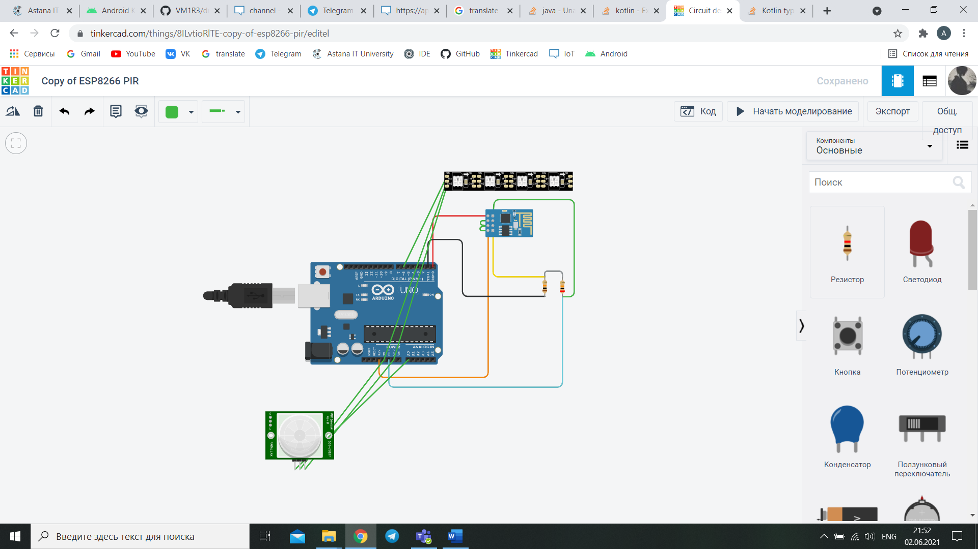

1. Explain what your app does and how it can be improved

First, we connected arduino with thingspeak, so that when the changes are installed, the result appears on IoT. After that, we connect the IoT with our android in order to transfer the result from the arduino to the phone again. Similarly, you can automate anything, and get the results of the action directly from your phone.

1. Send the github link with android app files

<https://github.com/VM1R3/draft>

1. Send the public link to Tinkercad project

<https://www.tinkercad.com/things/8ILvtioRlTE>

1. Send the link to public Thinkspeak channel

<https://thingspeak.com/channels/1405019>